Git Assignments

1.Create a directory ‘Project_dir’ and cd to ‘Progect_dir’.

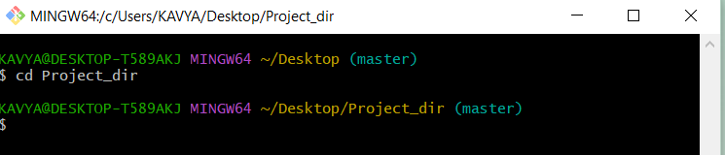

2.Initialize git version database.

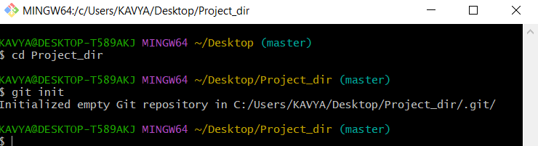

3.Create a new file index.html.

4.Check the git status. You should find index.html as untracked files.

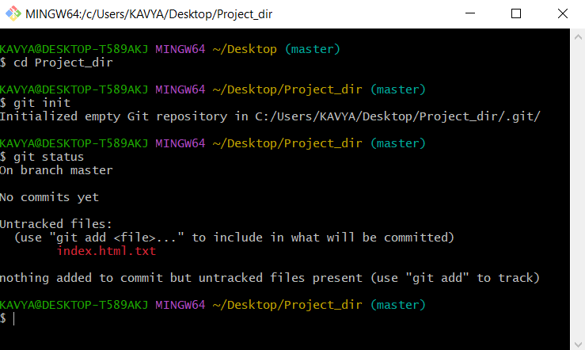

5. Stage the index.html.

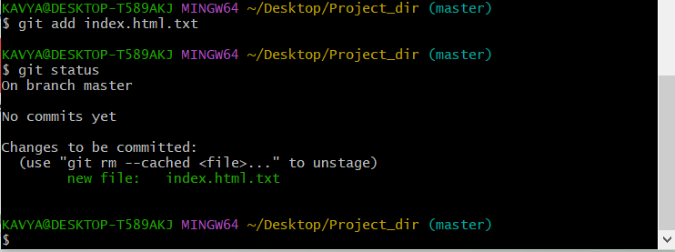

6. Commit index.html file.

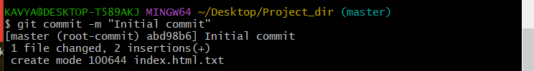

7. Make few changes in index.html & create a new file info.txt file.

8. Check git status. You should find index.html &info.txt as untracked files.

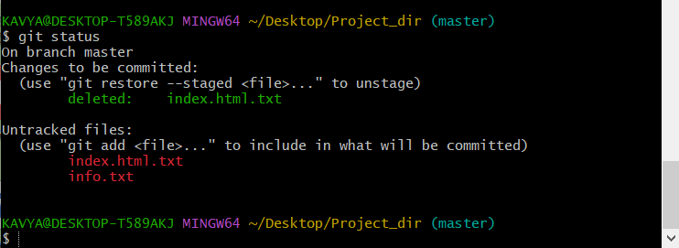

9. Configure git to ignore all txt files.



10. Again check the git status. You should find only index.html as untracked file.

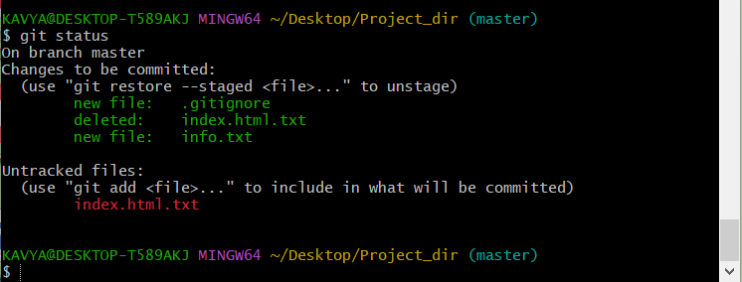

11. State & commit index.html.

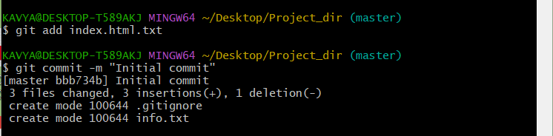

12. Log all your comments so far.

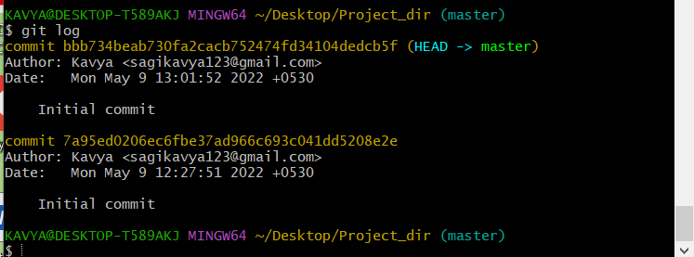

13. Make some changes in index.html.

14. Revert the change made in the previous step using git command.

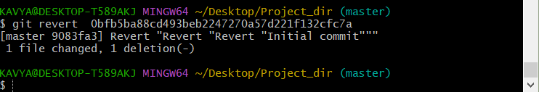

15. Again change index.html.

16. Stage index.html.



17. Revert back the last stage.

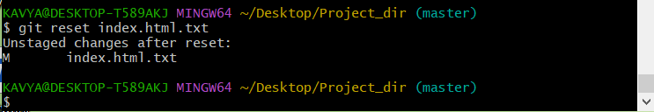

18. Rename ‘add’ command to ‘my_add’.

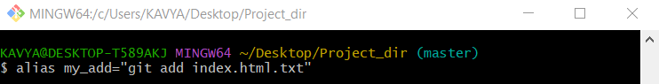

19. Using my_add command stage index.html again &commit the changes.

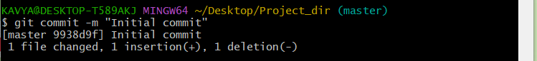

20. Revert the last commit.

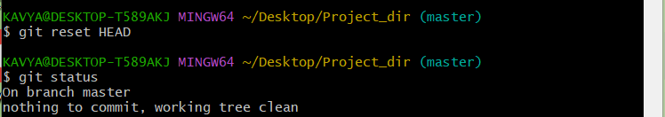

GIT Branching

22. Create an empty directory ‘Assignments’ & cd to ‘Assignments’.

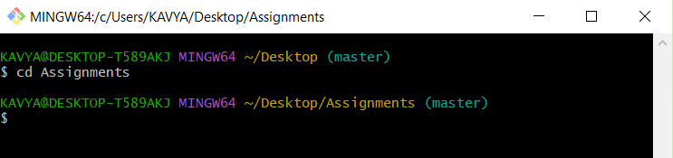

23. Create a file README.txt file inside ‘Assignments’ & write few lines about the contents of ‘Assignments’ folder.

24. Commit README.txt file.

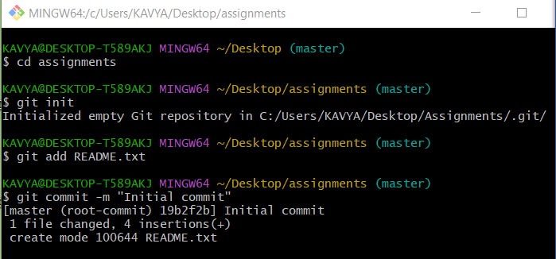

25. Now create a new branch ‘html-assignments’.

26. Switch to html-assignments’ branch.

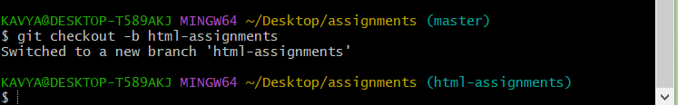

27. Copy all html assignments inside ‘Assignments’ folder.

28. Commit html assignments into ‘html-assignments’ branch.

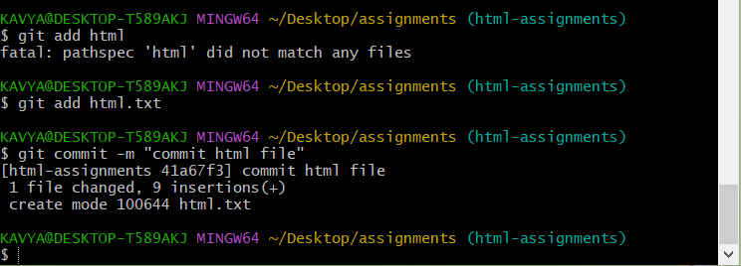

29. Make minor changes into few files belonging to ‘html-assignments’ branch.

30. commit those changed files.

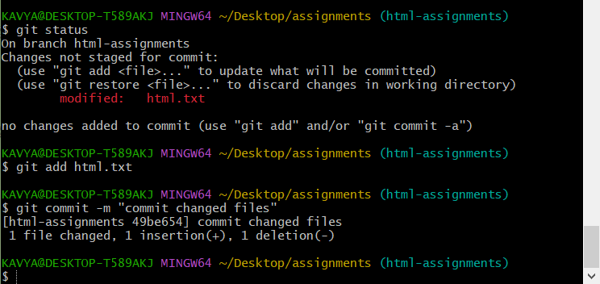

31. Switch to master branch.

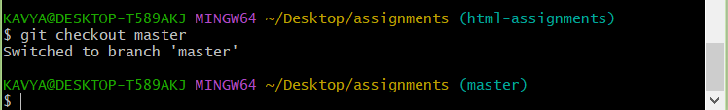

32. Make minor changes into few files into README.txt file & commit those changes into master.

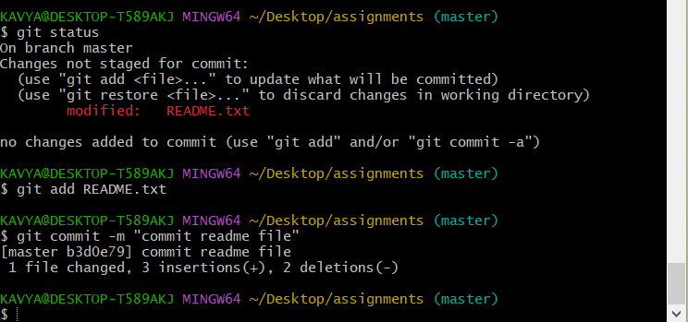

33. Again switch to ‘html-assignments’ branch.

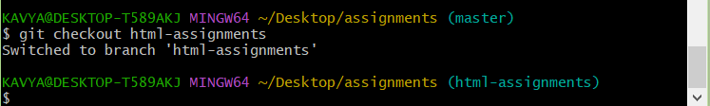

34. Make minor changes into few files belonging to ‘html=assignments’ branch.

35. commit those changes.

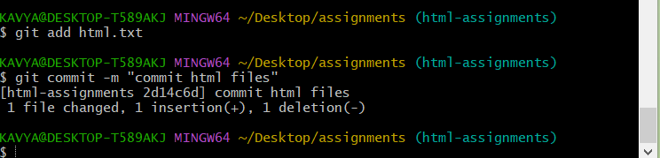

36. Switch to master branch.

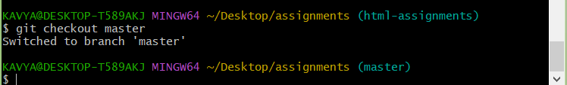

37. Merge ‘html-assignments’ branch into master. Confirm all html assignments are shown in master.

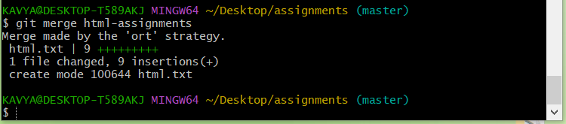

38. Finally delete the ‘html-assignments’ branch.

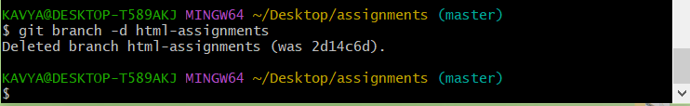

Section-2-CSS assignments

1.Create a new branch ‘css-assignments’.

2. Switch to ‘css-assignments’.

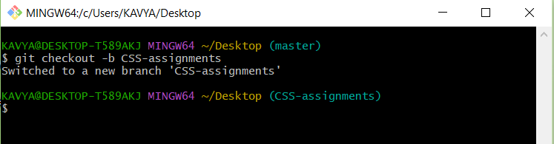

3. Copy all css-assignments inside ‘Assignments’ folder.

4. Commit all css assignments into Css-assignments.

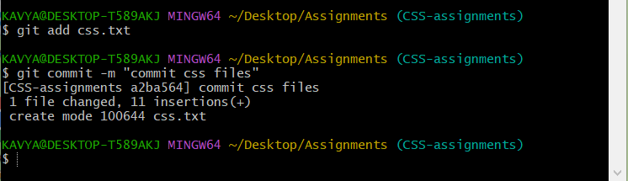

5. Make minor changes into README.txt file on line1 belonging to css-assignments branch.

6. Commit those changed files.

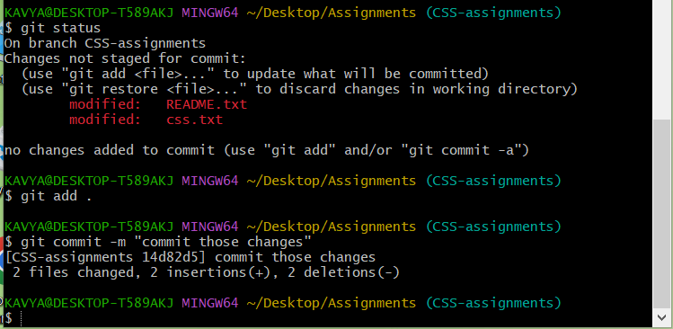

7. Switch to master branch.

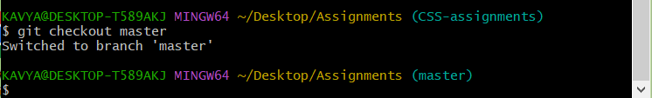

8. Make minor changes into README.txt file on line 3 & commit those changes into master.

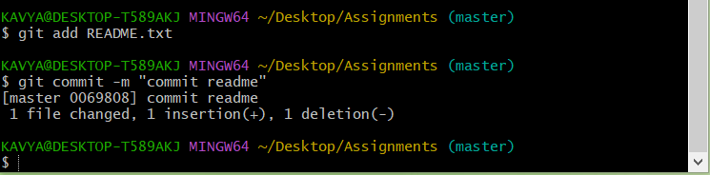

9. Again switch to css-assignments.

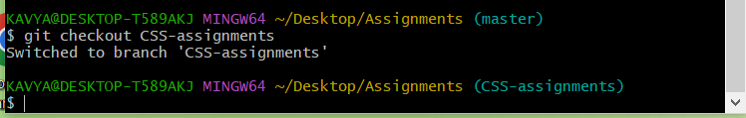

10. Make minor changes into few files belonging to css-assignments branch.

11. Commit those changes.

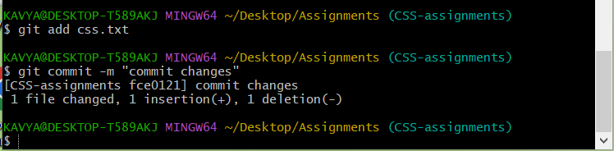

12. Switch to master branch.

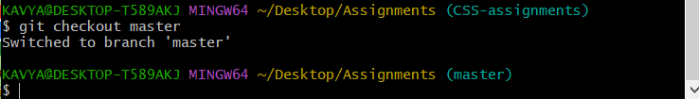

13. Merge css-assignments banch into master . confirm all css-assignments are shown in master.

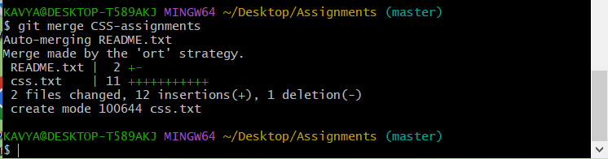

14. Finally delete the css-assignments.

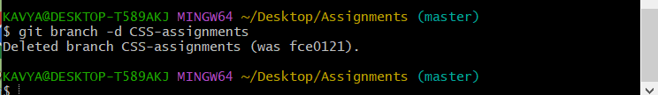

Section-3-Javascript assignments

1.Create a new branch ‘js-assignments’.

2. Switch to js-assignments branch.

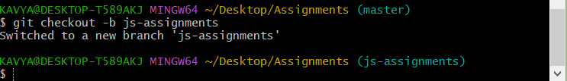

3. Copy all javascript assignments inside ‘Assignments’. Folder.

4. Commit JavaScript assignments into js-assignments branch.

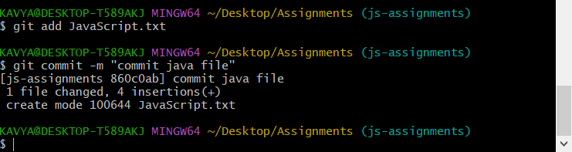

5. Make minor changes into README.txt file on line 1 belonging to js-assignments branch.

6. Commit those changed files.

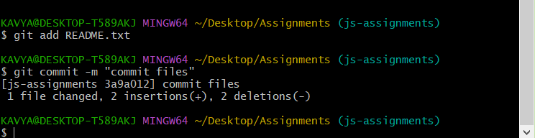

7. Switch to master branch.

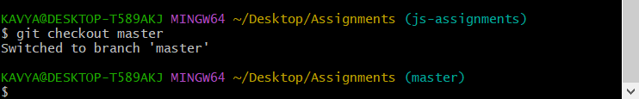

8. Make minor changes into README.txt file on line 1 & commit those changes into master.

9. Again switch to js-assignments branch.

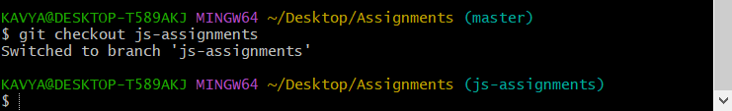

10. Make minor changes into few files belonging to js-assignments branch.

11. Commit those changes.

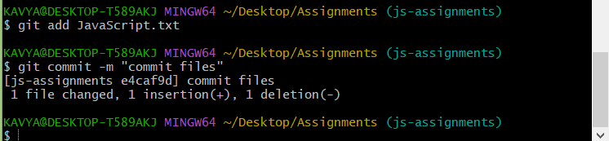

12. switch to master.

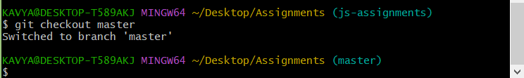

13. Merge js-assignments branch into master. Confirm all JavaScript assignments are shown in master.

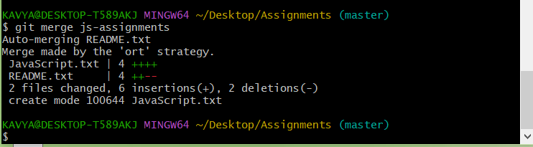

14. Finally delete the js-assignments.

